$Statistics session-5:Normal distribution$

$Defination of statstics$

$Inferential statistics$

$Descriptive statistics$

$Data types of variables$

$Levels of data$

$Popuation vs sample$

$Frequency table$

$Bar chart$

$Relative frequency table$

$Pie chart$

$Frequency distribution table$

$Histogram$

$Data distribution$

$How to make CI and width$

$Central tendency$

$Mean-Medain-Mode$

$Mean vs Medain$

$Outliers$

$Exact meaning of Mode in Distributions$

$Types of Distributions$

$Postive skew$

$Negative skew$

$No skew$

$Data dispersion$

$Range$

$Mean deviation$

$Absolute mean deviation$

$Variance$

$Standard deviation$

$Details of Normal distribution$

$Formulae of Normal distribution$

$Transformation methods$

$Emperical rule\left(68-95-99.7\right)$

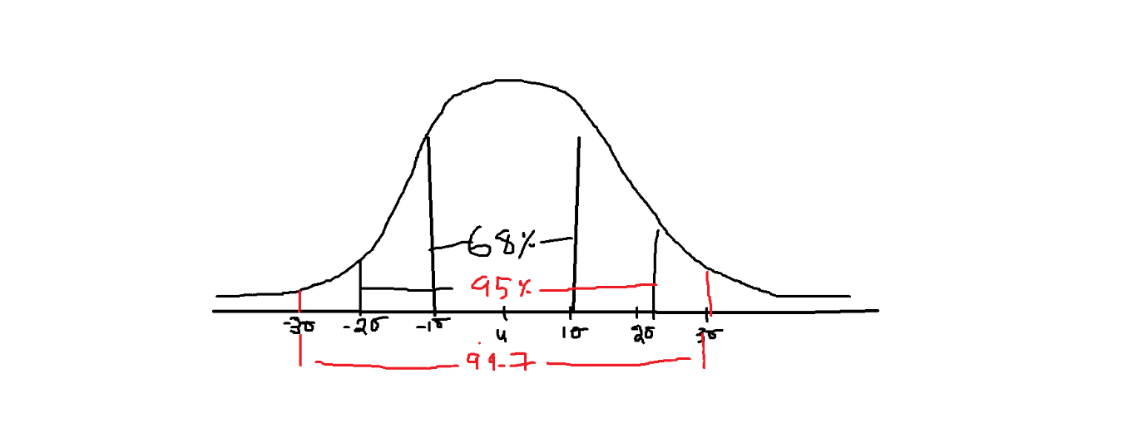

$standrad deviation=σ$

$population mean= μ$

$If a data follows Normal distribution$

$there are 68\% of data will cover between : u-1σ to u+1σ$

$there are 95\% of data will cover between : u-2σ to u+2σ$

$there are 99.7\% of data will cover between : u-3σ to u+3σ$

$the maximum data coverage will happens between-3σ to+3σ only$

$use case:$

$In India The average petrol rates are 100rs, It varies state by state$

$By 2 rs$

$standrad deviation=σ=2$

$population mean= μ=100$

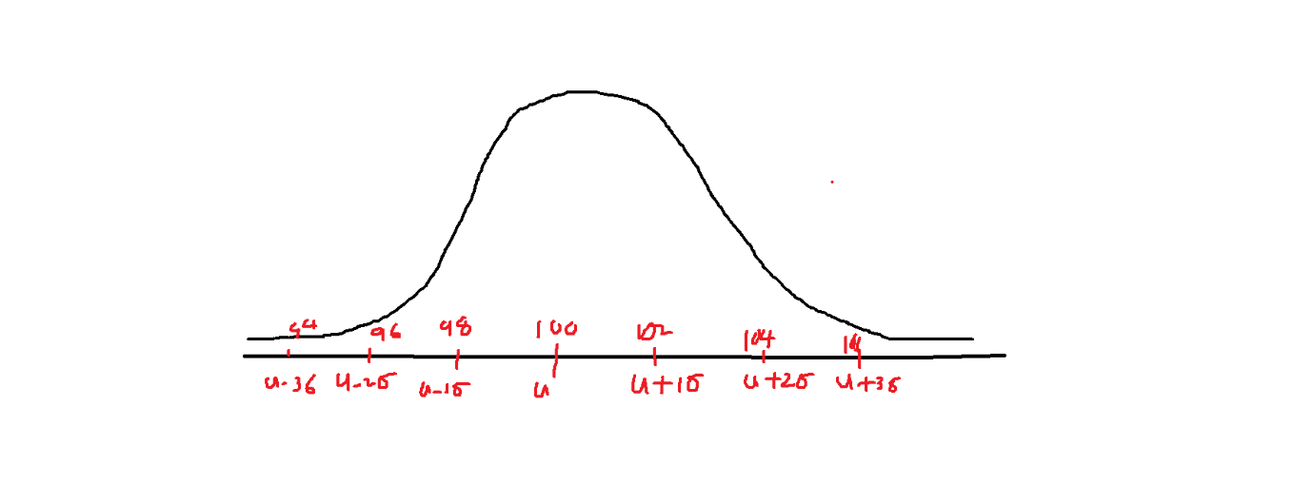

$there are 68\% of data will cover between :$

$u-1σ to u+1σ:$

$100-1*2 to 100+1*2=98 to 102$

$there are 95\% of data will cover between :$

$u-2σ to u+2σ$

$100-2*2 to 100+2*2=96 to 104$

$there are 99.7\% of data will cover between :$

$u-3σ to u+3σ$

$100-3*2 to 100+3*2=94 to 106$

$there is a 68\% of states in India has petrol rates between 98 to 102rs$

$there is a 95\% of states in India has petrol rates between 96 to 104rs$

$there is a 99.7\% of states in India has petrol rates between 94 to 106rs$

$30 satates 68\%\left(30\right)=22 states have 98 rs 102$

$The minimum petrol rate in India is 94rs$

$The maximum petrol rate in India is 106rs$

$The Emperical rule applicable only for Normal distribution data$

$If data does not follows Normal we will use another rule$

$Chebyshive inequlaity$

$u±k*σ k=1,2,3 Emperical rule$

$u±k*σ but the data percentage=1-\frac{1}{k^{2}}$

$k=2$

$u±2*σ$

$so data coverage=1-\frac{1}{k^{2}}=1-\frac{1}{2^{2}}=1-\frac{1}{4}=\frac{3}{4}=75\%$

$For 2 standard deviation the data coverage will be 75\%$

$k=3$

$u±3*σ$

$so data coverage=1-\frac{1}{k^{2}}=1-\frac{1}{3^{2}}=1-\frac{1}{9}=\frac{8}{9}=89\%$

$For 3 standard deviation the data coverage will be 89\%$

$k=0 there is no data coverage$

$for chebyshive data coverage starts from 2 standard deviation k≥2$

| Normal(Emerical) | Chebyshev (1-1/k^2) |
| --- | --- |
| $u-1σ to u+1σ=68$ | $u-1σ to u+1σ:Not valid= 1-\frac{1}{1^{2}}=0$ |
| $u-2σ to u+2σ=95$ | $u-2σ to u+2σ=75\%$ |
| $u-3σ to u+3σ=99.7$ | $u-3σ to u+3σ=1-\frac{1}{3^{2}}=\frac{8}{9}≅89\%$ |